**Midterm Assignment (Problem1 + Problem2 + Problem3)**

**INFO 7390 : Advances in Data Sciences/Architecture**

**Team 7**

**Chandni Sharma**

**Hari Panjwani**

**Sanath Shetty**

**Table Of Contents**

1. Problem Statement 3
2. Data Wrangling & Cleansing 4
3. Prediction 37
4. Classification 40
5. Forecast 52
6. References 65
7. **Problem Statement For Credit Card Dataset**

The aim of this project is to build a predictive model to in order to capture the potential customers who are likely to default or not pay their credit card bills. The date/period of credit card dataset ranges from April 2005 to September 2005. The raw data also contains the customer’s payment history, repayment status, Bill amount for that month, previous amount paid, his age as well as his education details.

* 1. **Goal:**
* Analyze the existing energy credit card dataset and develop an effective approach that can be used to detect customers who are more likely to default their payment
* Show trends based on various factors that influences the defaulter status of the customer
  1. **Applications:**
* Can be used by banks to check which customers would more likely be default customers based on their transactions over a period of time
* Recognizing a patterns and trends in their bill payment based on their personal details

1. **Data Wrangling & Cleansing**

The initial step was reading the data from the source and creating a dataset with column names in a more readable and verbose form. Then we proceeded with the data wrangling methods taught to us. We first took the summary of the entire dataset which helped us in understanding the nature of the data. Then we started excluding all the redundant data, rows with only zeros as well as empty transactions from the dataset. Then we restructured the data in such a way that we could capture the bill amount, amount paid and repayment status of a customer for a particular month. This resulted in each customer having their monthly transaction in a single row which helped us to analyze the data in a better way. We have them implemented feature engineering by creating a custom status variable based on the repayment status for each customer. By means of this status we can predict the list of customers who would most likely default their payments. Finally we consolidate the dataset by aggregating the data for each customer by his id.

**Outlier Analysis:**

By using the boxplot function we found out that there are many negative values for bill amount for a particular person which indicated that the person paid more than his actual bill during the previous month. We decided to create a threshold for eliminating the evident outliers in the bill amount by using the credit limit. We decided that we would remove customers who have a negative bill amount greater than 10% of credit limit.

**Boxplot (Code Snippet):**

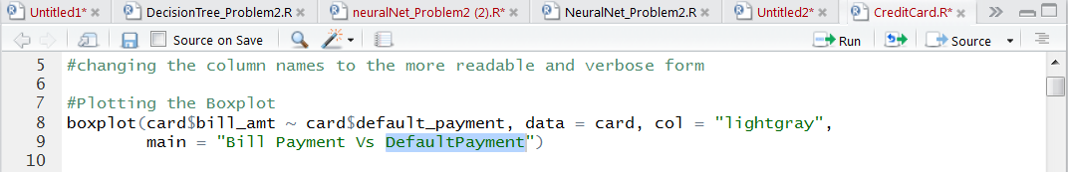

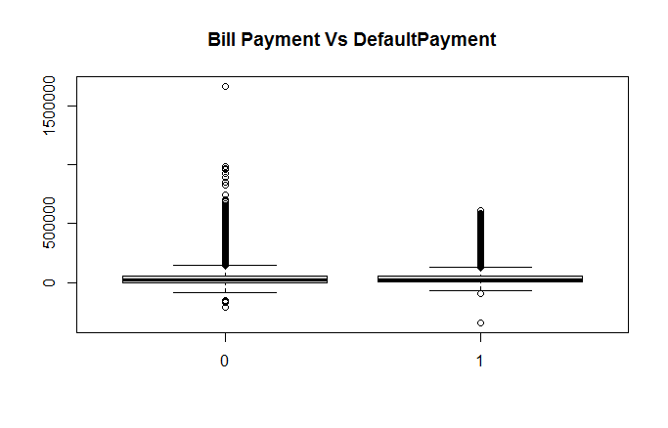

We also discovered that there are additional educational levels than the one defined in the metadata of our dataset. So we included all the other unspecified levels of education in education level = 4 which indicated “Others”

We then had a look at our data and found out that the month of September had no details for Amount paid. Since we do not have the amount paid by the customer in October we would not be utilizing the Bill Payment(September month) while building the model.

**Feature Engineering**

By using the repayment status, we are creating a custom status that would replace the five values of status in our model. The algorithm that we used to develop the custom status is as follows:

We initially create 4 columns-

1. Occurrence of minimum due payment i.e. number of times 0’s appear (**Minimum Amount Paid)**
2. Occurrence of late payment by 1 month i.e. number of times 1’s appear (**One month late)**
3. Occurrence of late payment by 2 month i.e. number of times 0’s appear (**Two month late)**
4. Occurrence of late payment by 3 month or more i.e. number of times 3’s or others appear (**Three months or later)**

**Step1:** Replace repayment status -2 by -1. As both indicate the same thing that the customer is duly paying his bills

**Step2 :** Replace status > 2 by 3. Our observation is based on the fact that in the given dataset if a person is delaying his payment for more than 3 months, he is more likely to be a defaulter. By doing so we are creating a biased model aiming to capture people who are likely to default.

**Step3 :** After getting the values of new columns, we replace the NA’s with zero

**Step4 :** Creating a biased model by penalizing the customer, by taking weighted average and create a feature named status

Status = (Occurrence of -1’s) * (Penalty i.e. 1 in this case) +

(Occurrence of 0’s) * (Penalty i.e. 2 in this case) +

(Occurrence of 1’s) * (Penalty i.e. 3 in this case) +

(Occurrence of 2’s) * (Penalty i.e. 4 in this case) +

(Occurrence of 3’s) * (Penalty i.e. 5)

**Step5** : After this we normalize the score for status in the range of 0-1

**Step6** : We finally use this column while building the model instead of 4 repayment statuses

Finally we drop month, repayment status and other columns which are not essential.

1. **Model Selection**

**3.1. Logistic Regression**

We start by reading the credit card dataset to the CreditData, prepared during the Data Wrangling part. We then take a sample size in the ratio of 0.75: 0:25 and split the CreditData into train and test dataset. We use the train dataset to train our logistic regression model and the test dataset to predict the default payment in the test dataset based on the model created on the train dataset.

After running the logistic regression model on the train dataset we get the following results for the parameters used in our model:

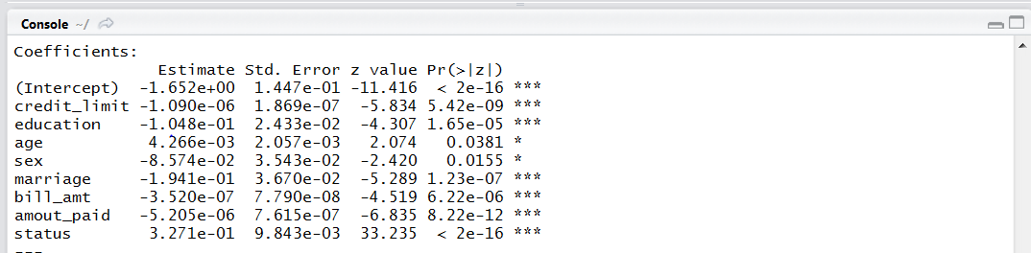

**McFadden Co-efficient Code Snippet:**

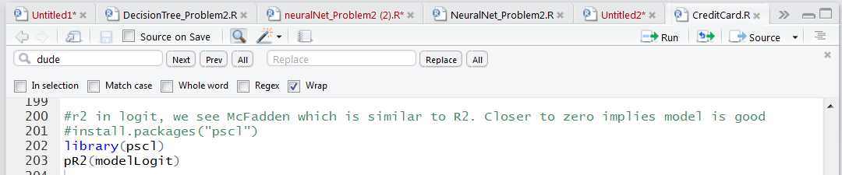

**McFadden Co-efficient Result:**



**ROC Curve for Logistic Regression**

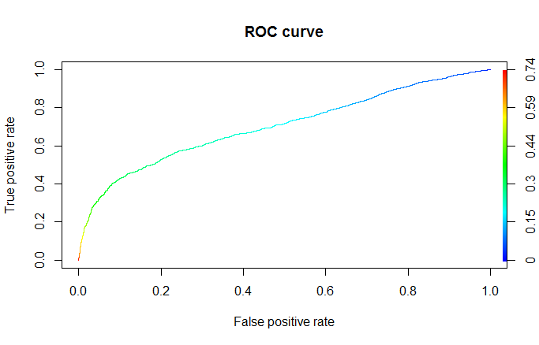

Fig: ROC Curve

**ROC Curve for Logistic Regression**

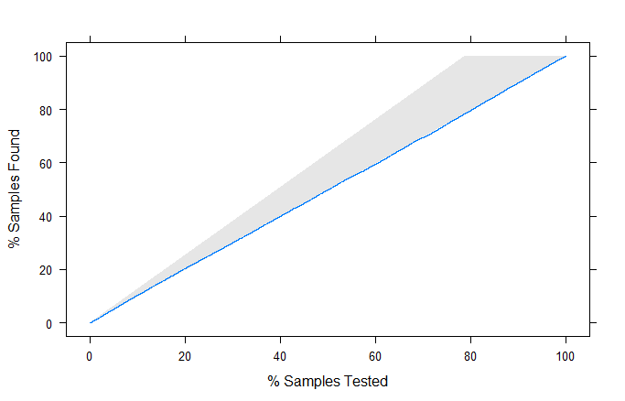

Fig : Lift Curve

**Overall Error**



**Confusion Matrix**



**3.2. Decision Tree**

We start by reading the credit card dataset to the CreditData, prepared during the Data Wrangling part. We then take a sample size in the ratio of 0.75: 0:25 and split the CreditData into train and test dataset. We use the train dataset to train our decision tree model and the test dataset to predict the default payment in the test dataset based on the model created on the train dataset.

After running the decision tree model on the train dataset we get the following results for the parameters used in our model

Plot for Regression Tree (Unpruned):

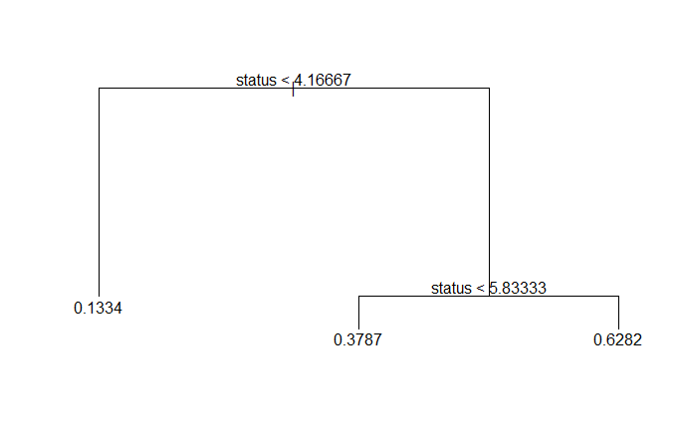

Now we check for the cross validation graph to check for the level of pruning that is required.

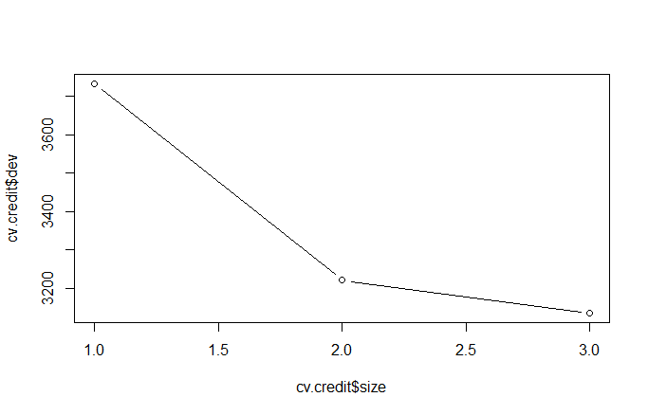

**Fig: Cross Validation Graph**

From the above graph we can see that there is no deviation on standard deviation after cv.credit$size =2.0.

On Pruning the dataset by selecting the best 4 levels we get the following plot for Regression Tree



**Fig : Pruned Decision Tree**

Now we check for the cross validation graph to check for any changes after the level of pruning is applied.



As it can be seen our mean value gets increased after applying the pruning. Hence, we stick the model of the Regression Tree without pruning.

**Overall Error**

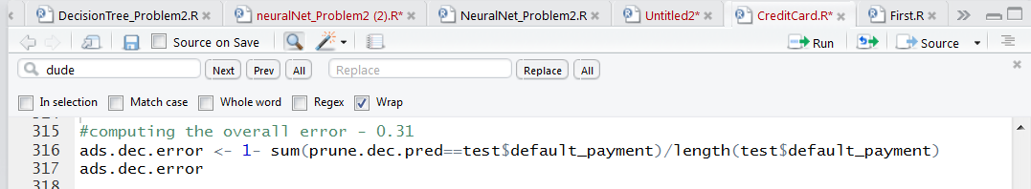

Overall Error: 0.31

**Confusion Matrix :**

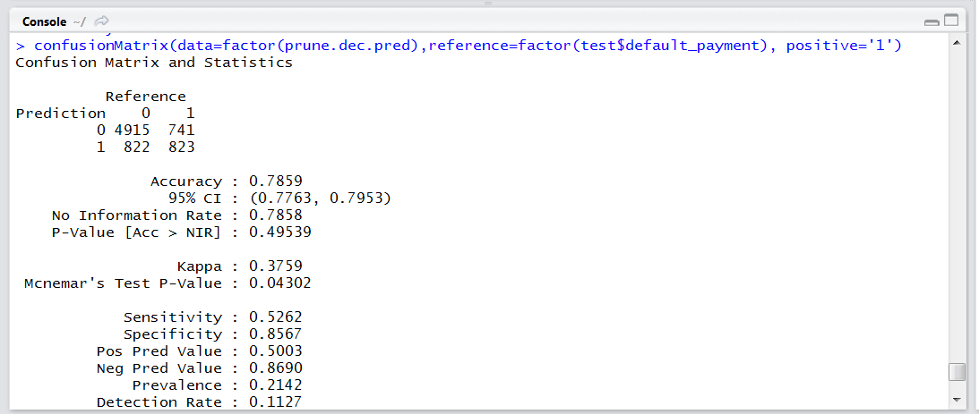

**ROC Curve for Decision Tree**

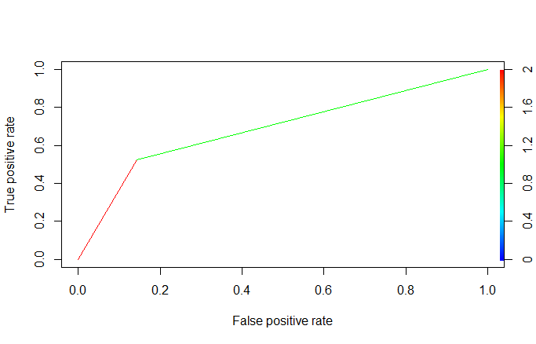

Fig: ROC Curve

**Lift Curve for Decision Tree**

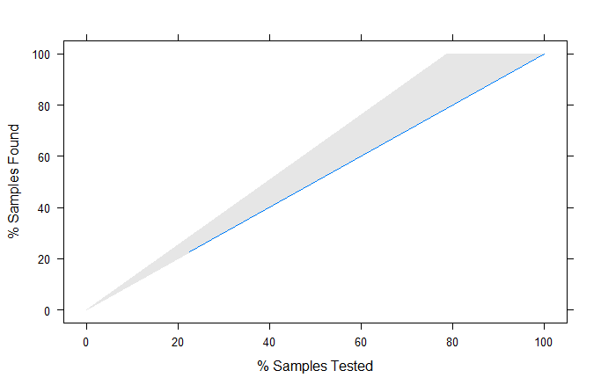

Fig : Lift Curve

**3.3 Neural Network**

We start by reading the credit card dataset to the CreditData, prepared during the Data Wrangling part. We then take a sample size in the ratio of 0.75: 0:25 and split the CreditData into train and test dataset.

Now we run the neural network algorithm on the train dataset for the response column default payment. We have included credit_limit, sex, marriage, bill_amount, amout_paid, status input parameters on the model.

In the neural network we first need to normalize/scale the data before splitting it into train and test dataset. We applied the neural network function on the train dataset. Initially we were facing a lot of issues while running the neural network model due to lack of understanding of its parameters and hence we were facing the issue of always going beyond the given step size while building the network.

By iterating through this process we learnt that we were giving a low threshold value and hence it was not able to train the model. Also by increasing the parameters/neurons in the hidden layers helps our case because it easily helps to train the model

**Plot for the Neural Network**

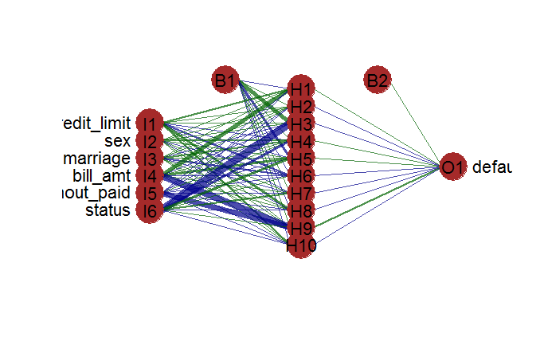

Fig : Neural Network

**Overall Error**

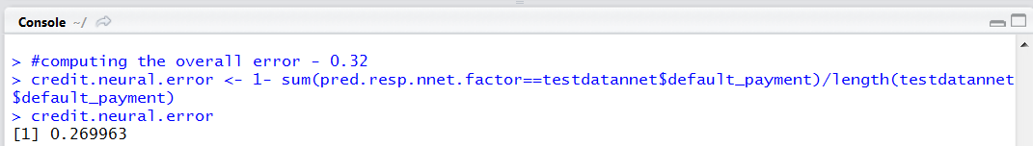

Overall Error: 0.32

**Confusion Matrix :**

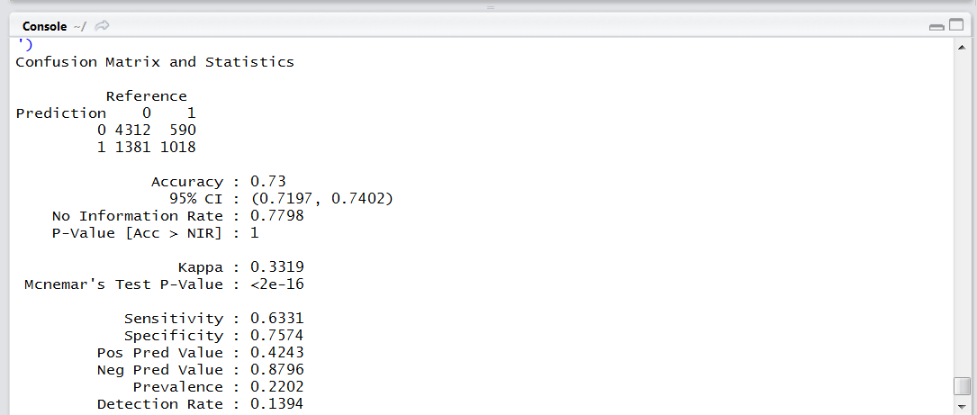

**ROC Curve for Decision Tree**

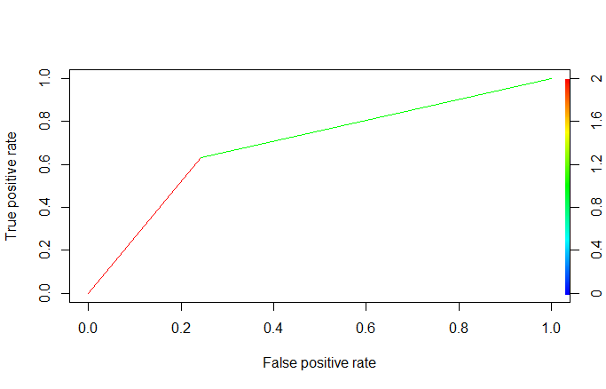

Fig: ROC Curve

**Lift Curve for Decision Tree**

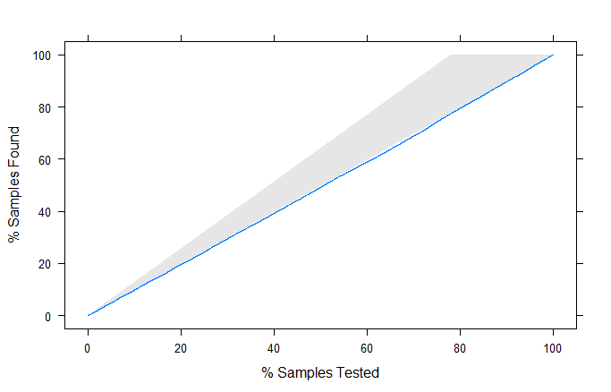

Fig : Lift Curve

**Conclusion**

We have three models with two models having accuracy of approximately 80% and other one is of 73%. We chose the model with 73% accuracy because the ROCR curve, lift curve indicates, if there is large data to predict the neural net will work fast an better and the sensitivity of this model is also better. Since, we need to find the defaulters, we can take the risk of asking questions from the genuine person but we don’t want to miss even a single defaulter. Therefore, for this case scenario neural networks best with sensitivity of 63% and specificity of 76%.

1. **Analysis on Prediction**

**Visualization 1:**

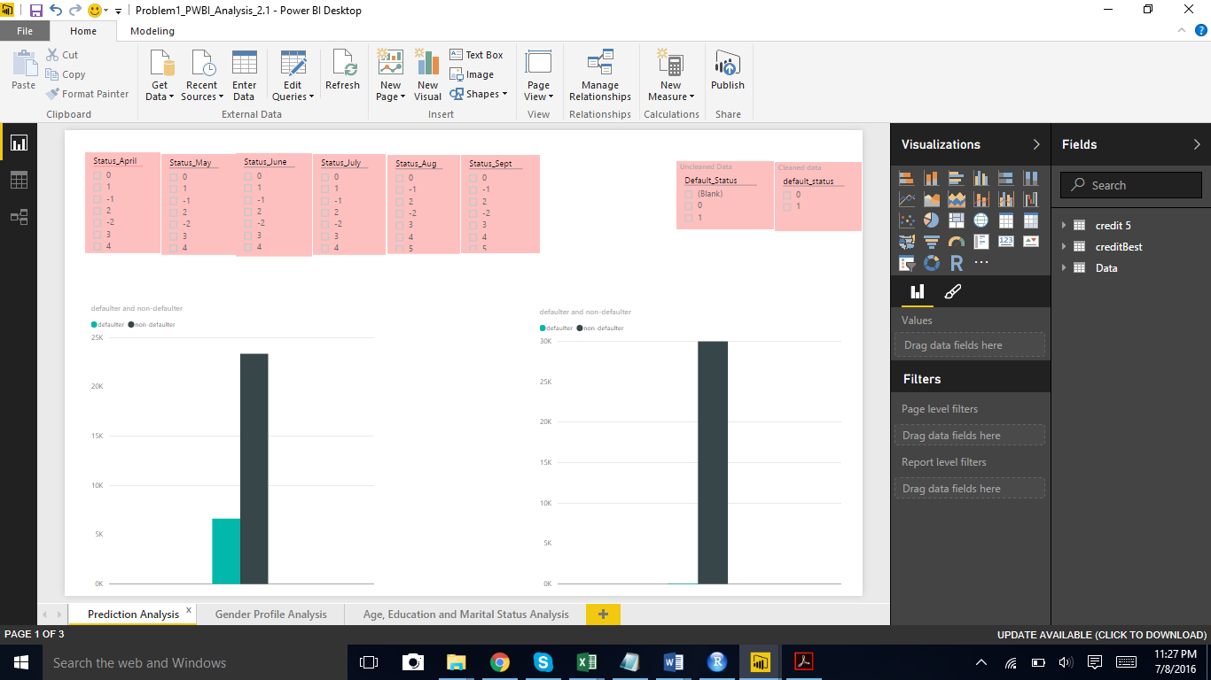

We observe that the prediction results have been very near.

For the expected prediction results data - we had observed 6636 Non-Defaulters and Defaulter as 23366.

We had received good prediction rates from our models.

We further used the prediction values for our cleaned data comparison.

**Visualization 2:**



On the basis of our cleaned data, we observed that 68.33% females are Non-defaulters while the remaining 32% percentage of males are non-defaulters.

We also observed that 50% females are defaulters while the remaining 50 % percentage of males are defaulters.

We can further filter on the Age group.

**Visualization 3:**

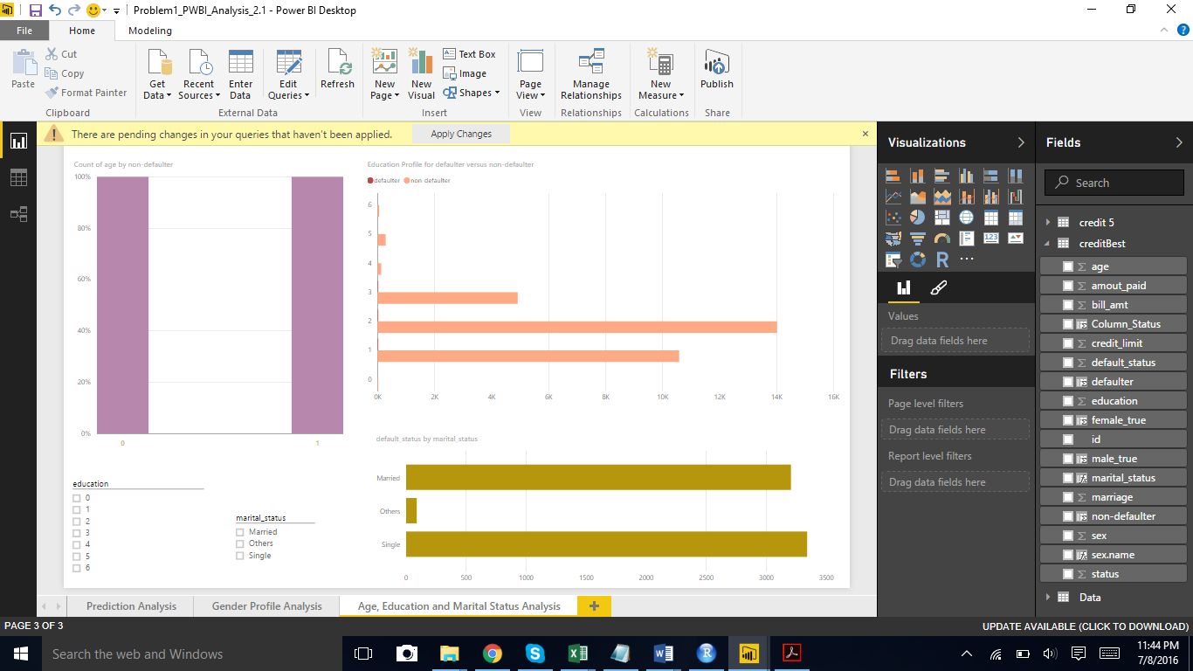

We observed that maximum non-defaulters have received University level of education.

Second highest number of non-defaulters are from Graduate Level of education.

From the marital status perspective, a very high percentage of the defaulters are single which is followed by a close number of married defaulters.

The average age of non-defaulter is 35 and for defaulter it is 36.

1. **Refrences**

* Wunderground.com: <https://www.wunderground.com/weather/api>
* WeatherData : <https://cran.r-project.org/web/packages/weatherData>
* Power Factor: <https://en.wikipedia.org/wiki/Power_factor>
* A guide to reactive power-EDF Energy: <https://www.edfenergy.com/sites/default/files/b2b-guide_to_reactive_power.pdf>

1. **Problem Statement For Ad/Non-Ad Dataset**

Many Internet sites draw income from third-party advertisements, usually in the form of images sprinkled throughout the site's pages. If judged to be interesting or relevant, users can click on these so-called banner/advertisements, jumping to the advertiser's own site.

* 1. **Goal:**
* Analyze the existing internet advertisement dataset and develop an effective approach that can be used to detect whether an image in a page is an ad or non-ad.
* Show trends based on various factors that influences the probability of the image being an advertisement.
  1. **Applications:**
* Recommend which account number or facility needs to be monitored and educate the citizens with suggestions for optimal usage of energy
* Make a note of consumption trends with respect to temperature, day of the week, month or even a particular day
* Recognizing a pattern in the usage to identify peak hour for daily energy consumption

1. **Data Wrangling & Cleansing**

The initial step was reading the data from the source and creating a dataset with column names in a more readable and verbose form. Here we had two separate raw data one containing the actual data and the other data set containing column. So we had too structure our dataset with column values that correspond to their respective rows. Also values for height, width, aaratio were represented as factors while the data was read into the dataset. We then converted it into numeric type. Also we transformed the last column classes which were ad and non-ad into 0/1.

**Outlier Analysis:**

As seen in the dataset there are missing values which constitute to about 28% of the entire data. We segregate these values from the entire dataset and store it in a different dataset for the time being. This being a major chunk of the data we can’t delete it neither can we replace it with any calculations from our dataset at this point because it contains a lot of outliers.

By using the boxplot function we found out that there are many outlier values for the numeric columns for a particular image.

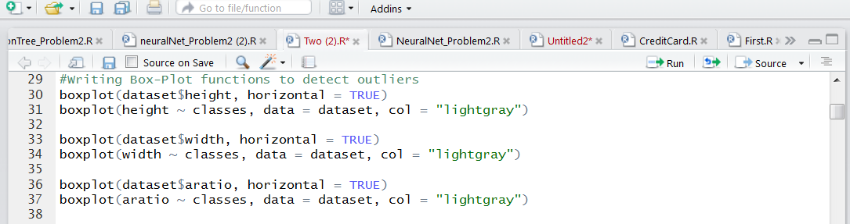

Fig: Code Snippet for Boxplot

Snapshots of Outliers:

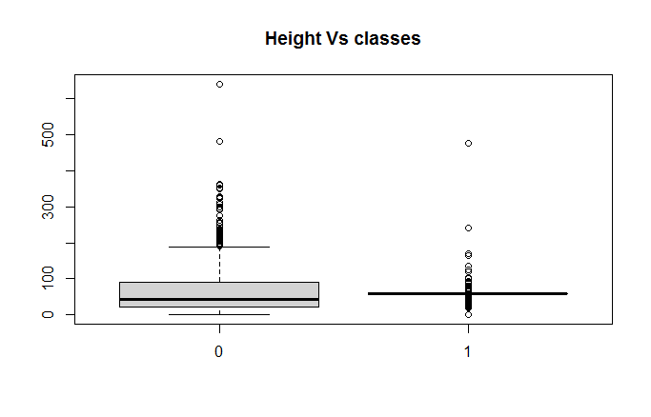

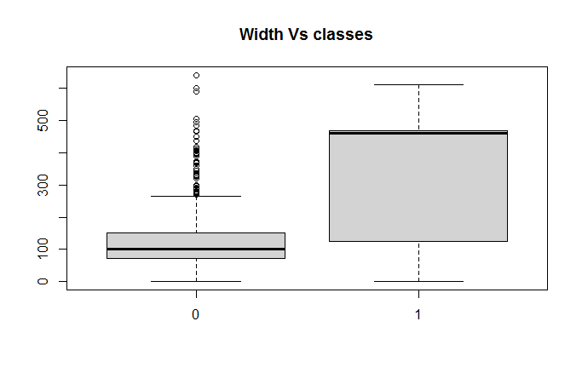

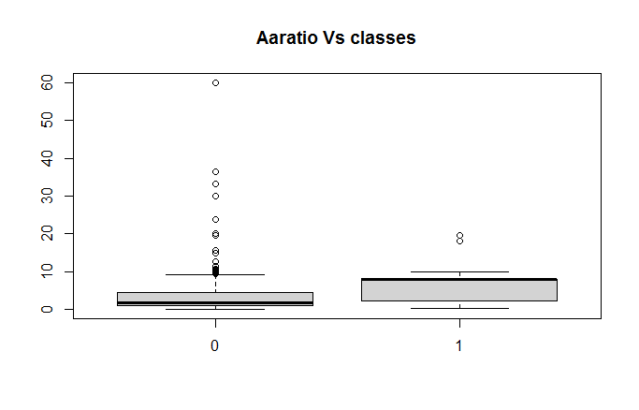

We handled these outliers using some outlier functions like the ones given below we were able to get around 1 percent data as outliers from the entire dataset.

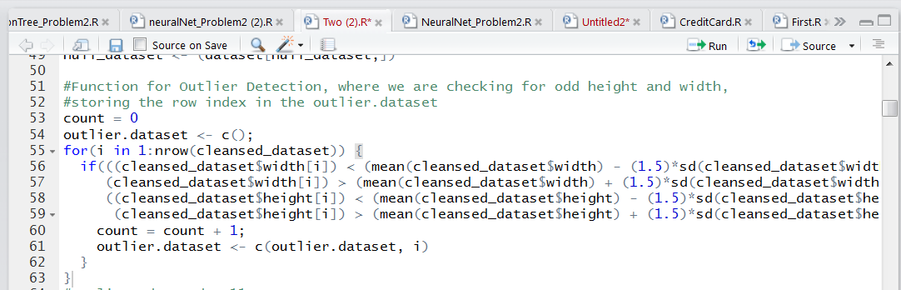

Some other functions are as follows:

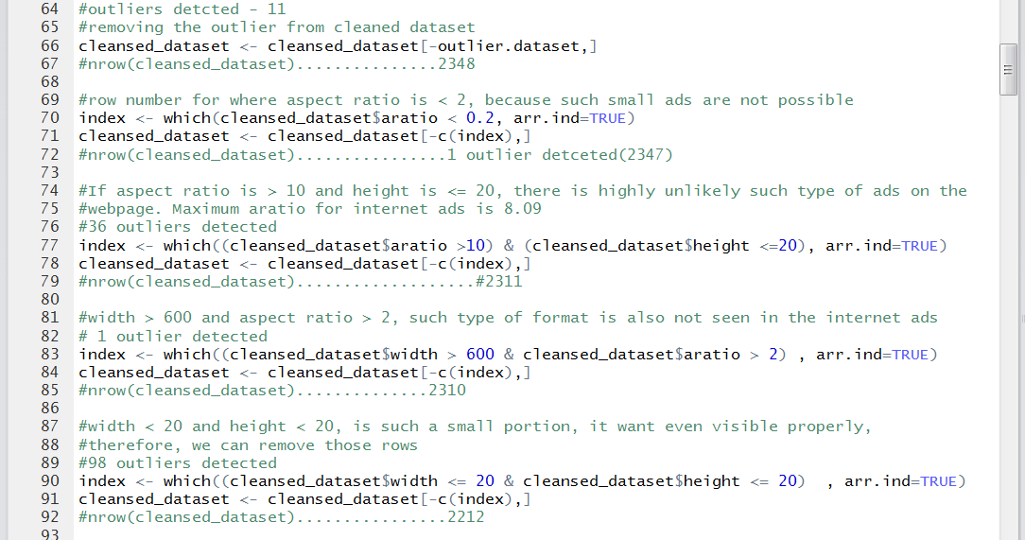

Now we bind the null dataset with the cleaned dataset. We create a custom function to fill the missing data in our newly created dataset which is as follows:

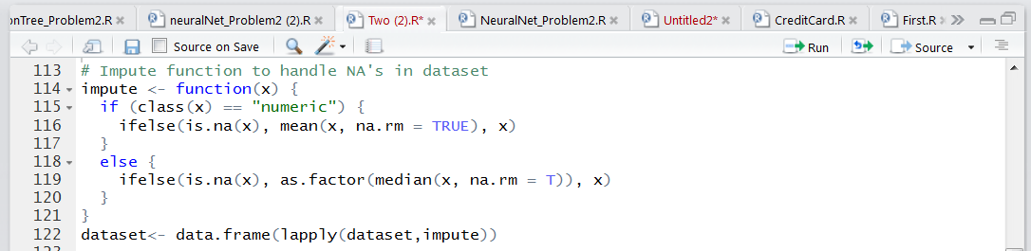

**Dimension Reduction:**

As you can see the dataset contains a lot of columns about 1559 it becomes difficult to predict the variable importance. So we need to use dimension reduction to narrow down to the important dimensions.

We use the Principal Component Analysis approach to solve this problem.

Code Snippet for PCA



With the help of PCA we are now able to narrow down the dimensions from 1559 to about 498 dimensions.

1. **Model Selection**

**3.1. Logistic Regression**

We start by reading the InternetAd data from the source file to the consolidated dataset, prepared during the Data Wrangling part. We then take a sample size in the ratio of 0.75: 0:25 and split the dataset into train and test dataset. We use the train dataset to train our logistic regression model and the test dataset to predict whether an image is an ad/non-ad in the test dataset based on the model created on the train dataset.

After running the logistic regression model on the train dataset we get the following results for the parameters used in our model:

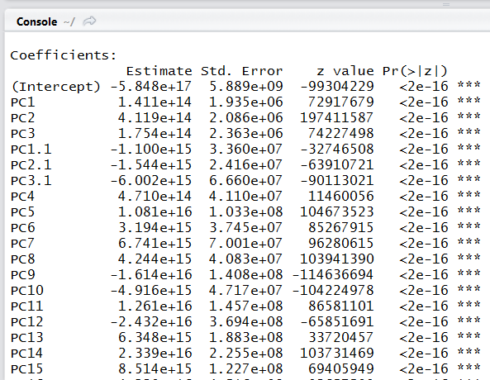

**McFadden Co-efficient Code Snippet and Result:**

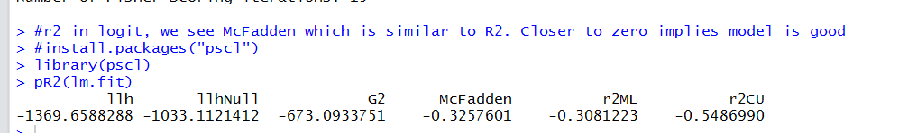

**ROC Curve for Logistic Regression**

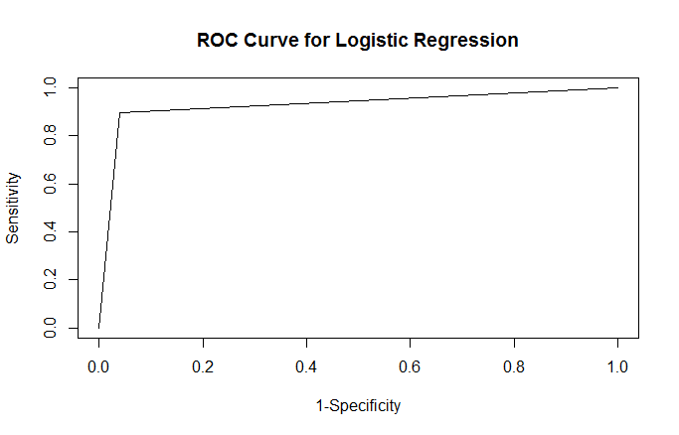

Fig: ROC Curve

**Lift Curve for Logistic Regression**

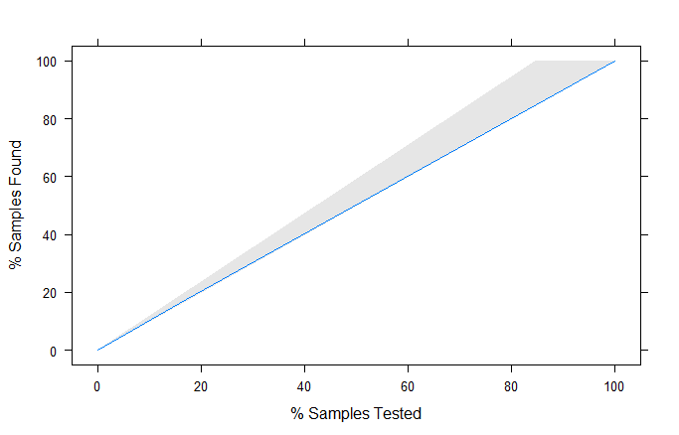

Fig : Lift Curve

**Overall Error**



Overall Error : 0.049

**Confusion Matrix**

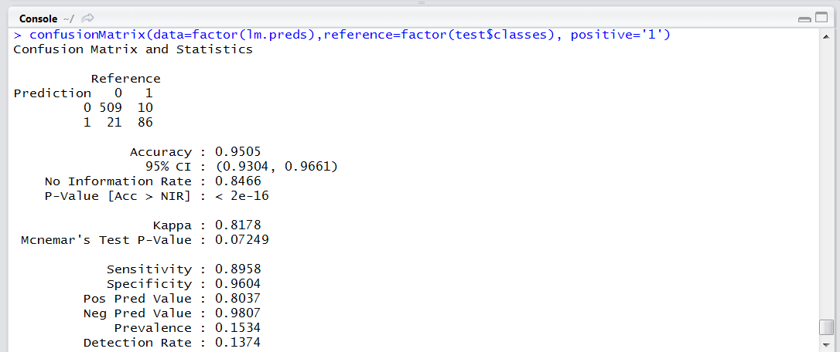

**3.2. Decision Tree**

We start by reading the InternetAd data from the source file to the consolidated dataset, prepared during the Data Wrangling part. We then take a sample size in the ratio of 0.75: 0:25 and split the dataset into train and test dataset. We use the train dataset to train our logistic regression model and the test dataset to predict whether an image is an ad/non-ad in the test dataset based on the model created on the train dataset.

After running the decision tree model on the train dataset we get the following results for the parameters used in our model

Plot for Regression Tree (Unpruned):

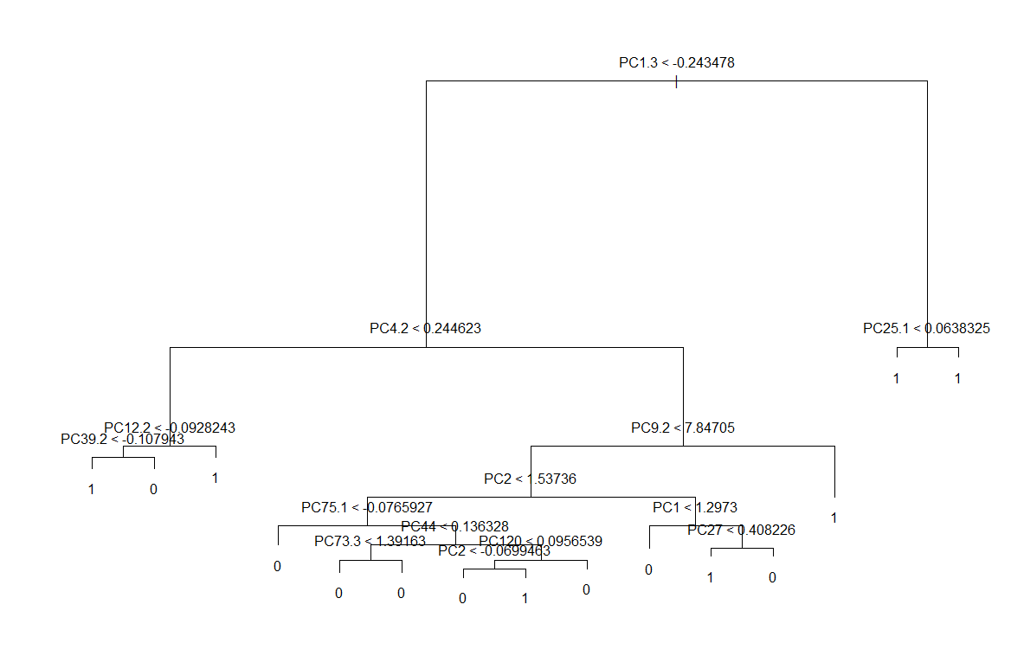

Now we check for the cross validation graph to check for the level of pruning that is required.

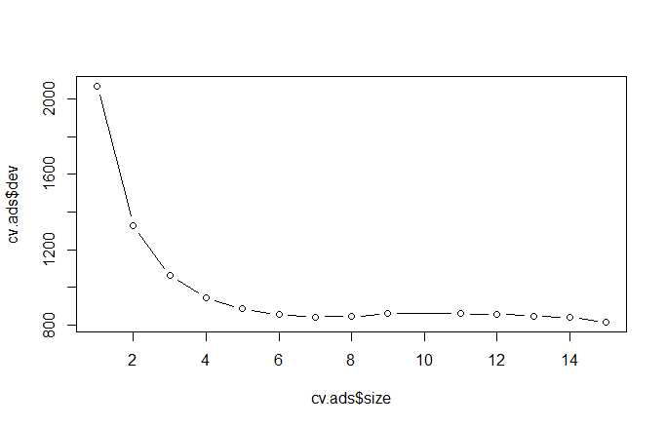

**Fig: Cross Validation Graph**

From the above graph we can see that there is no deviation on standard deviation after cv.ads$size =6.0.

On Pruning the dataset by selecting the best 10 levels we get the following plot for Regression Tree

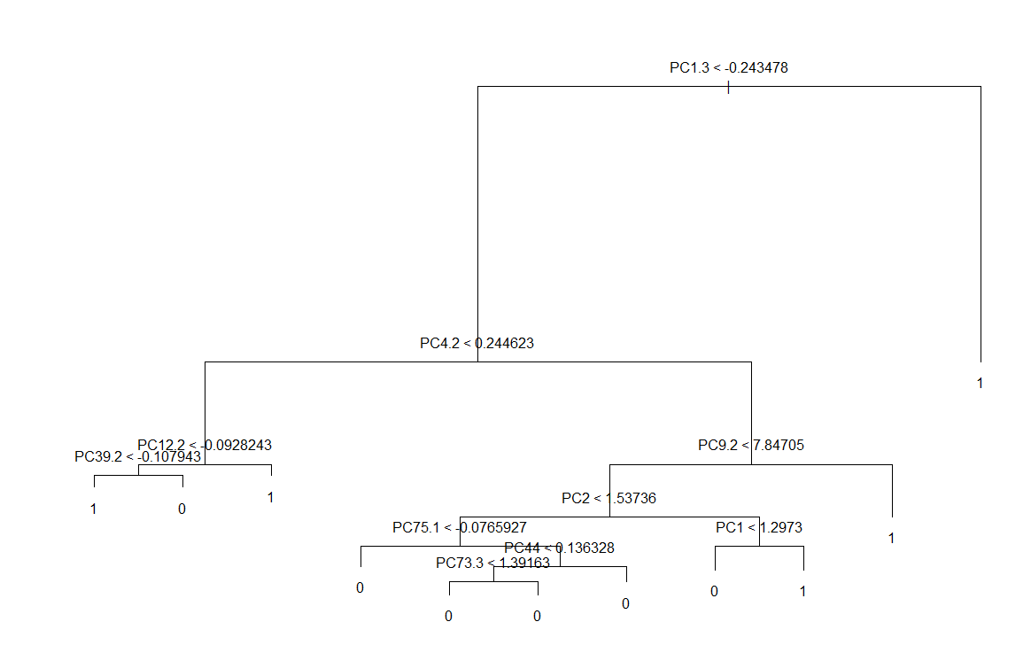

**Fig : Pruned Decision Tree**

Now we check for the cross validation graph to check for any changes after the level of pruning is applied.

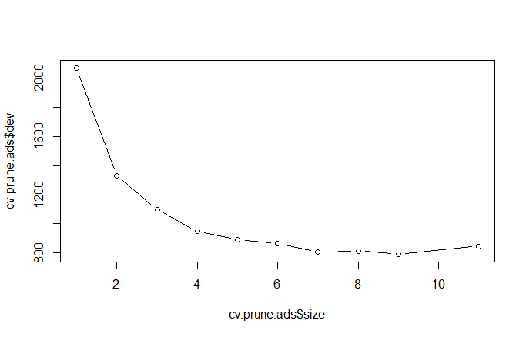

As it can be seen our mean value gets increased after applying the pruning. Hence, we stick the model of the Regression Tree with pruning.

**Overall Error**



Overall Error: 0.027

**Confusion Matrix :**

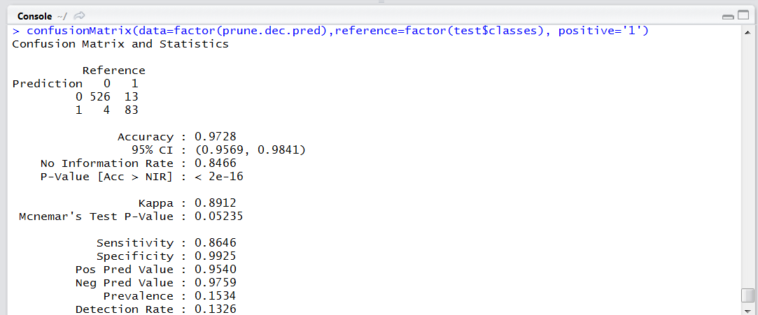

**ROC Curve for Decision Tree**

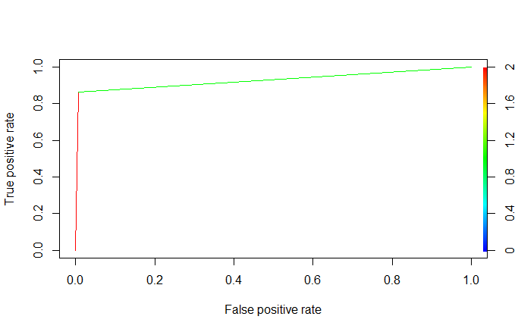

Fig: ROC Curve

**Lift Curve for Decision Tree**

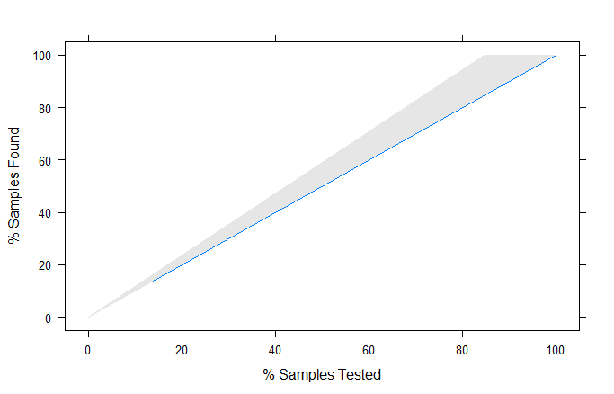

Fig : Lift Curve

**3.3 Neural Network**

We start by reading the credit card dataset to the CreditData, prepared during the Data Wrangling part. We then take a sample size in the ratio of 0.75: 0:25 and split the CreditData into train and test dataset.

Now we run the neural network algorithm on the train dataset for the response column default payment. We have included credit_limit, sex, marriage, bill_amount, amout_paid, status input parameters on the model.

In the neural network we first need to normalize/scale the data before splitting it into train and test dataset. We applied the neural network function on the train dataset. Initially we were facing a lot of issues while running the neural network model due to lack of understanding of its parameters and hence we were facing the issue of always going beyond the given step size while building the network.

By iterating through this process we learnt that we were giving a low threshold value and hence it was not able to train the model. Also by increasing the parameters/neurons in the hidden layers helps our case because it easily helps to train the model

**Plot for the Neural Network**



Fig : Neural Network

**Overall Error**



Overall Error: 0.0408

**Confusion Matrix:**

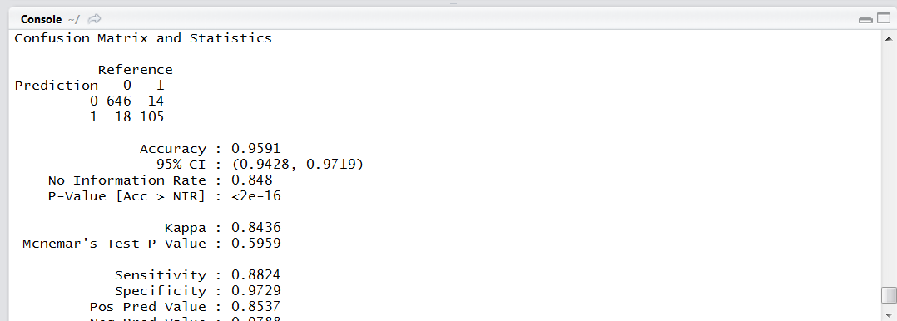

**ROC Curve for Decision Tree**



Fig: ROC Curve

**Lift Curve for Decision Tree**



Fig : Lift Curve

**Conclusion**

Although we have pretty high accuracy for each model, which choose Logistic Tree as our final model because the sensitivity of the model is highest among others i.e., 90%. Our problem is to identified whether the data is ad or not, therefore we need the sensitivity to be high, not just accuracy.

1. **Prediction Based on Analysis**

**Visualization 1: Height,Width & local wrt Ad/Non-Ad**

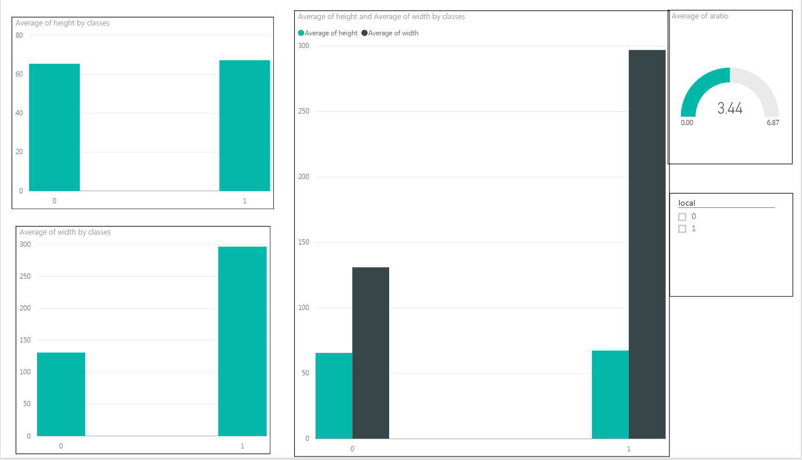

Based on our predicted dataset we have created a few visualizations. The visualization gives us the average height and width for an image to be an ad which is 100 * 300

Also it tell us that the average aratio(width/height) for an ad is 3.63.

The ad and non ad also depends on the variable local which indicates whether the url provided in the image is hosted internally (local=0) or externally (local =1…….in this case most of the times it is an ad)

**Visualization 2 : Some Interesting Patterns**

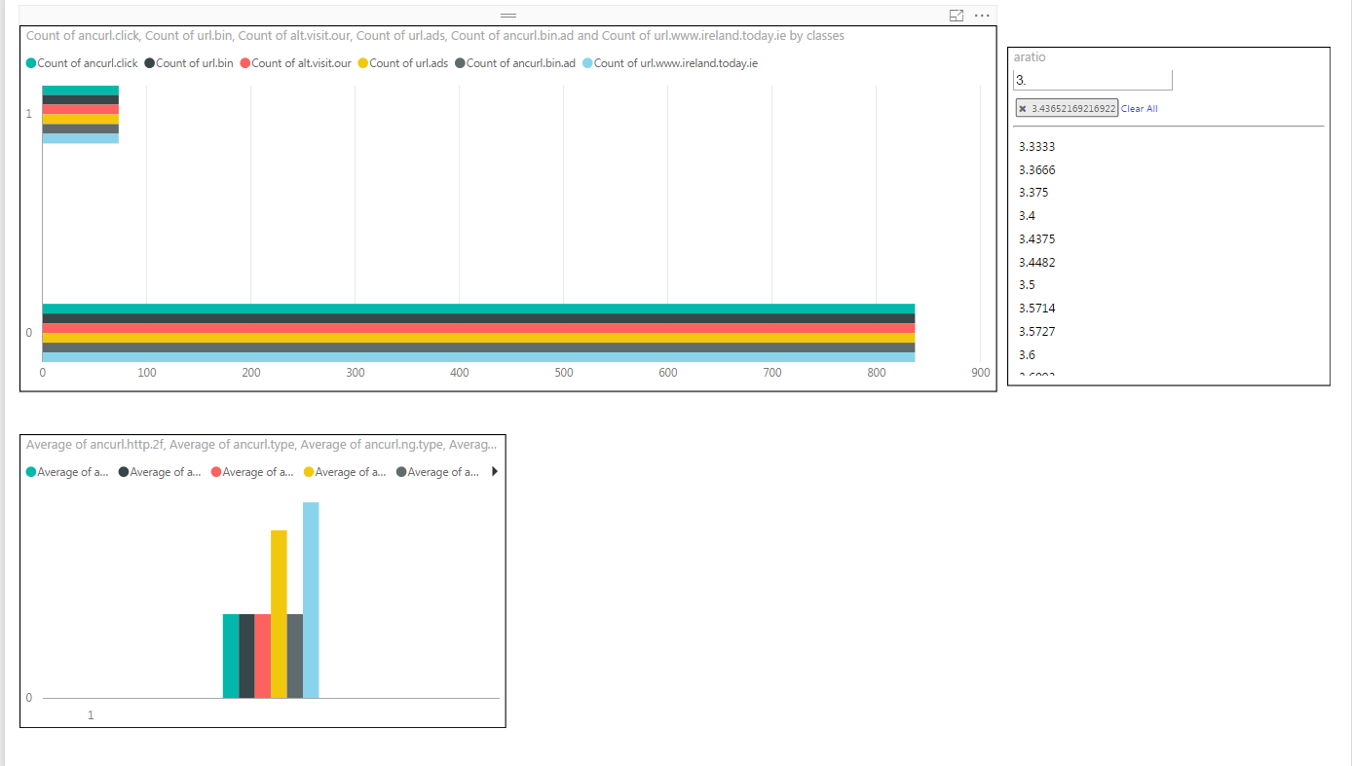

So while visualizing we found an interesting pattern that for aspect ratio > 3.4 and for a series of variables like the ones below in the snapshot , the prediction is an ad.

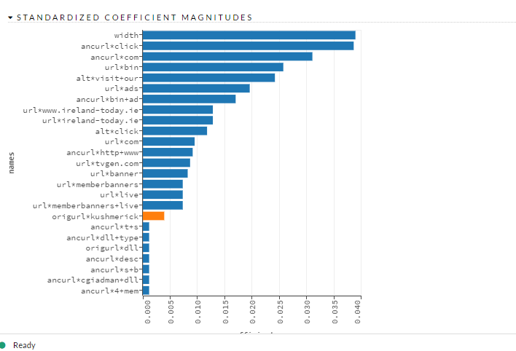

1. **Problem Statement for Predicting Power**

This problem mimics the operation 48-hour ahead prediction of hourly power generation at 7 wind farms, based on historical measurements and additional wind forecast information (48-hour ahead predictions of wind speed and direction at the sites). The data is available for period ranging from the 1st hour of 2009/7/1 to the 12th hour of 2012/6/28.

* 1. **Goal:**
* Analyze the historical data of wind power at seven different farms and analyze zonal and meridional wind components of wind forecast done in the past and develop an effective approach that can be used to forecast the power generation for seven farms.
* Show trends based on various factors that influences the power generation, like wind director, wind speed etc.
  1. **Applications:**
* Recommend which account number or facility needs to be monitored and educate the citizens with suggestions for optimal usage of energy
* Make a note of consumption trends with respect to temperature, day of the week, month or even a particular day
* Recognizing a pattern in the usage to identify peak hour for daily energy consumption

1. **Data Wrangling & Cleansing**

The initial step was reading the training data from the source and creating a dataset and change the format of the date. After that we have seven columns of wind power generation, each representing different farm. We transpose the data from column to row which an additional row representing the farm and another column represent the wind power of that farm at that particular time. After this we are reading the wind forecast file for each farm and then separating the hours from the date. After that we are removing the rows which has NA’s. Since the file itself is a prediction of 48 hours ahead. The trend which we is followed is every hour of every date occurs 4 times in a dataset. To the make the data consistent we aggregated the rows based on farm, date and hour and took the mean of u, v, ws and wd(parameters given in the wind forecast file).

**Outlier Analysis:**

Outlier Analysis is started once the data become consistent in both the data frames. We used boxplot to observe the trend and apart from that there were 83 values which has **u** as zero’s and 93 rows which **v** as zero’s. We replaced zero’s with NA and then used na.locf to fill the rows, what na.locf does is it takes the above or below value and fill the NA. Since the wind director or speed won’t much change much in an hour, we thought it is best way to approach this problem. NA in wind power generation file are also filled with na.locf, there were about 2000 rows with zero’s

By using the boxplot function we found out that there are not many outlier values for u, v, ws, wd or wind power



Fig: Wind Speed Boxplot



Fig: Wind Direction Boxplot



Fig: Meridional Component Boxplot



Fig: Zonal Component Boxplot



Fig: Wind Power of Seven Farms

We aggregated the data from each farm and consolidated in single data frame, so that it will be easier to train a model with farm as one parameter.

After aggregating the data among wind forecast, we left join the data frame with the train data frame which has dates and wind power from July 2009 to June 2012. After this we separated the frame based on date. Date values which are less than 2011-01-01 00:00:00 are used for training the model. We also the turn column which tells power forecasted for particular date is happened on 00th hour or 12th hour.

1. **Model Selection**

**3.1. Logistic Regression**

We start by reading the wind farm data, the consolidated file which we created after following the data wrangling steps This file has data from date 2009-07-01 01:00:00 till 2010-12-30 00:00:00. It also have column with zonal, meridional and wind components along with wind power forecasted. We then take a sample size in the ratio of 0.75: 0:25 and split the dataset into train and test dataset. We use the train dataset to train our logistic regression model and the test dataset to check the accuracy of the model of predicting the wind power ahead of 48 hours.

After running the logistic regression model on the train dataset we get the following results for the parameters used in our model:



**McFadden Co-efficient Code Snippet and Result:**



**Performance Matrices of Logistic Regression**



Fig: Performance Matrices

**3.2. Decision Tree**

We start by reading the wind farm data, the consolidated file which we created after following the data wrangling steps This file has data from date 2009-07-01 01:00:00 till 2010-12-30 00:00:00. It also have column with zonal, meridional and wind components along with wind power forecasted. We then take a sample size in the ratio of 0.75: 0:25 and split the dataset into train and test dataset. We use the train dataset to train our decision tree model and the test dataset to check the accuracy of the model of predicting the wind power ahead of 48 hours.

After running the decision tree model on the train dataset we get the following results for the parameters used in our model

Plot for Regression Tree (Unpruned):



Now we check for the cross validation graph to check for the level of pruning that is required.



**Fig: Cross Validation Graph**

From the above graph we can see that there is no deviation on standard deviation after cv.ads$size =4.0.

On Pruning the dataset by selecting the best 4 levels we get the following plot for Regression Tree



**Fig : Pruned Decision Tree**

Now we check for the cross validation graph to check for any changes after the level of pruning is applied.



As it can be seen our mean value gets decreased after applying the pruning. Hence, we took the prune model for the prediction of the Regression Tree.

**Performance Metrices**



**3.3 Neural Network**

We start by reading the wind farm data, the consolidated file which we created after following the data wrangling steps This file has data from date 2009-07-01 01:00:00 till 2010-12-30 00:00:00. It also have column with zonal, meridional and wind components along with wind power forecasted. We then take a sample size in the ratio of 0.75: 0:25 and split the dataset into train and test dataset. We use the train dataset to train our neural net model and the test dataset to check the accuracy of the model of predicting the wind power ahead of 48 hours.

In the neural network we first need to normalize/scale the data before splitting it into train and test dataset. We applied the neural network function on the train dataset. Initially we were facing a lot of issues while running the neural network model due to lack of understanding of its parameters and hence we were facing the issue of always going beyond the given step size while building the network.

By iterating through this process we learnt that we were giving a low threshold value and hence it was not able to train the model. Also by increasing the parameters/neurons in the hidden layers helps our case because it easily helps to train the model

**Plot for the Neural Network**



Fig : Neural Network

**Performance Metrices**



**Conclusion**

After working with Regression, Neural Network and Regression Tree, we decided to the select the Decision Tree as our primary model. Neural Network is not good, since the values are widely scattered, it took a long time to train the neural net. Value for Logistic Regression and Regression Tree, we feel Regression tree would be a better because after predicting when we analyzed that values are much closer and they were all positive whereas in logistic regression was predictive some negative values as well, which shall not be the case.

1. **Forecast**

**Forecasting Analysis Based on Prediction**

Decision-making problems relating to an optimal management of wind power generation in power systems and electricity markets require different types of forecasts as input.

**Windfarm Prediction 1 -**

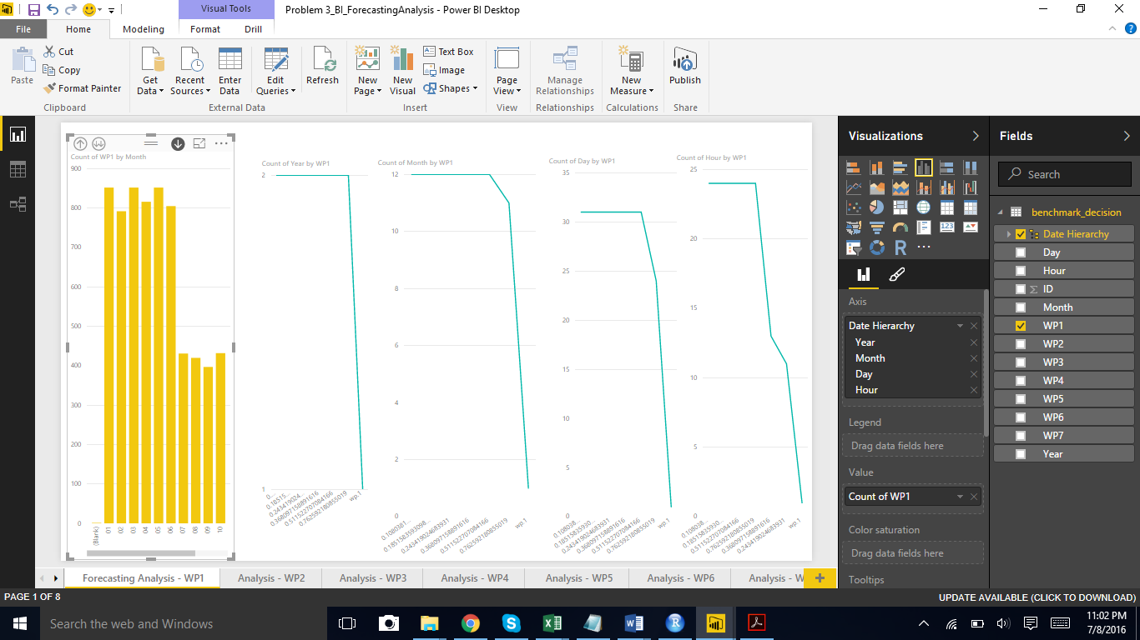

We observe that the forecasting values have decreased over the period of year. As we see in the above graph for the years, the count 2 is the second year – 2012 and the count 1 is the first year – 2011.

There is a steeping decrease in the forecasting values as per the month (From January towards the end of the year).

We observe similar pattern for the days seeing that there is a steeping decrease in the forecasting values as per the days (From 1st onwards).

However, the forecasting values for hourly basis is not decreasing evenly. There is a different pattern observed.

We have kept the Date Hierarchy for drilling down or up to understand the overall changes over the time period.

Also we have shown the change as per the individual date attributes.

Similarly, we can observe the pattern for the Windfarms predictions - WP 2, WP3, WP4, WP5, WP6 and WP7

For the results of Windfarm 1, there are 2 shifts in the decreasing rate for Day 24 and 31.

**Windfarm Prediction 2 -**

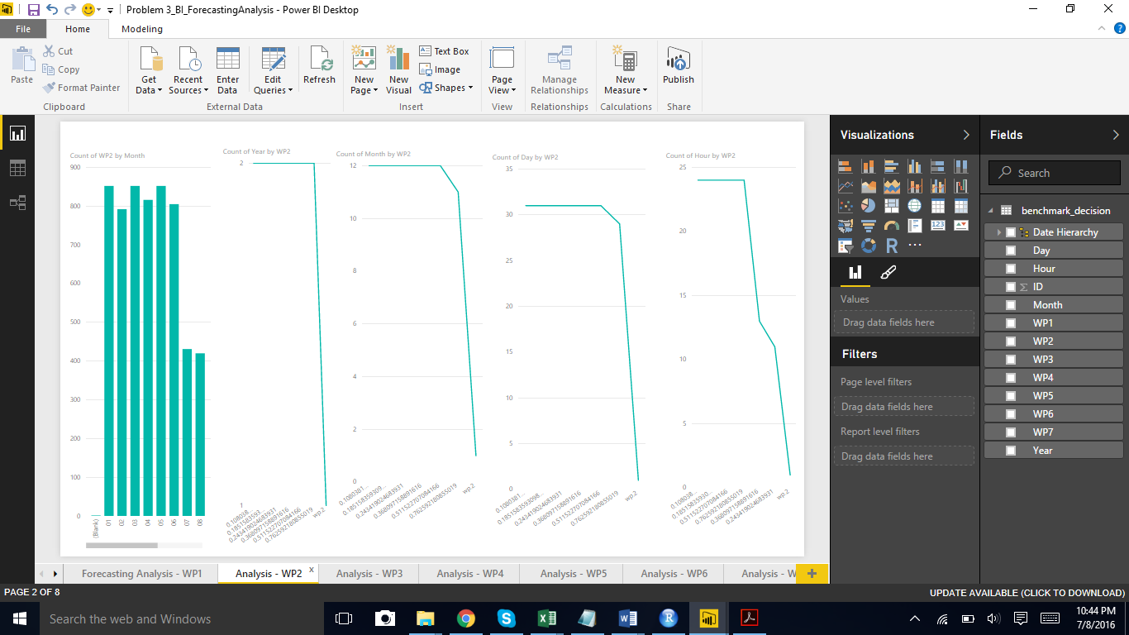

For the results of Windfarm 2, there are 2 shifts in the decreasing rate for Day 29 and 31.

**Windfarm Prediction 3 –**

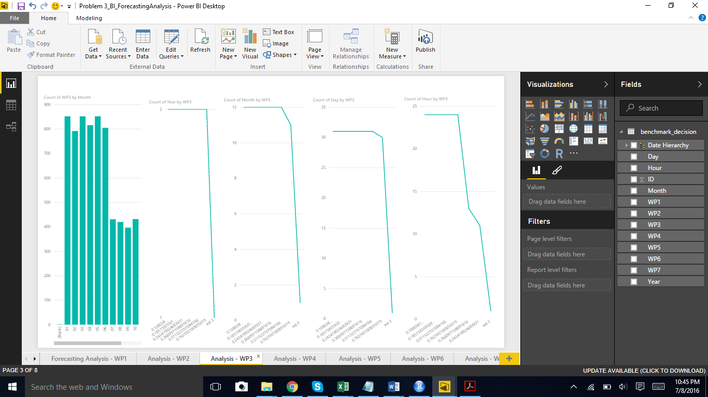

For the results of Windfarm 3, there are 2 shifts in the decreasing rate for Day 30 and 31.

**Windfarm Prediction 4 -**

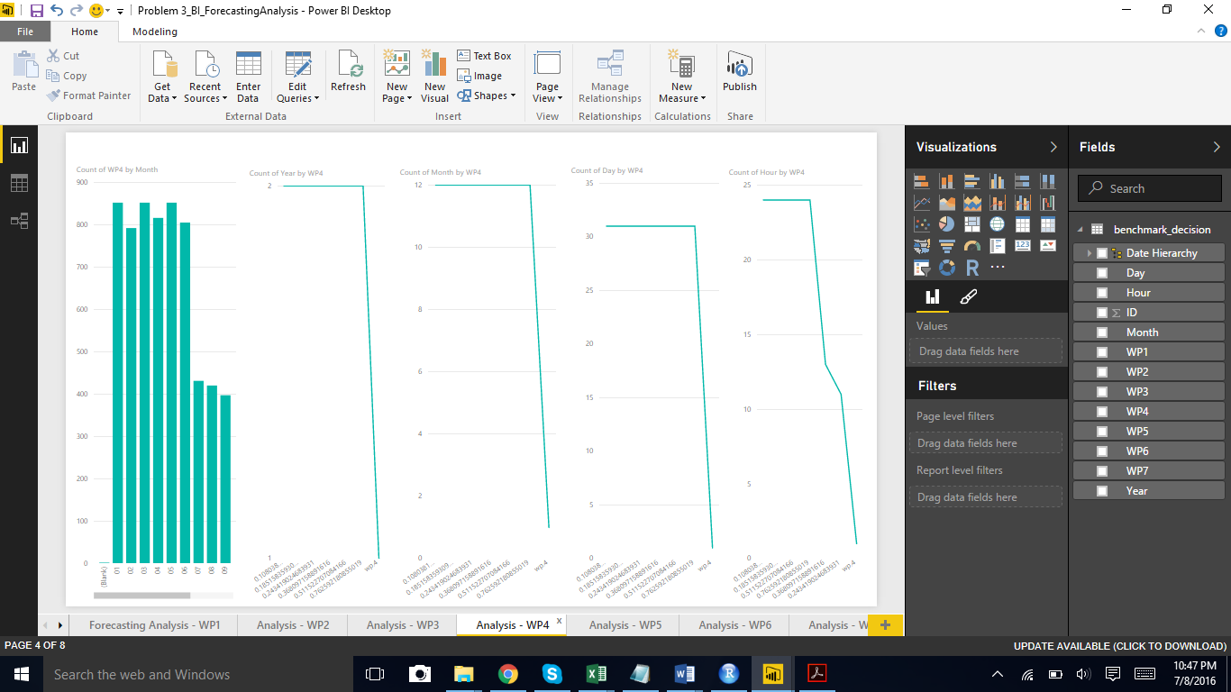

For the results of Windfarm 4, there is only 1 shifts in the decreasing rate for Day 31.

**Windfarm Prediction 5-**

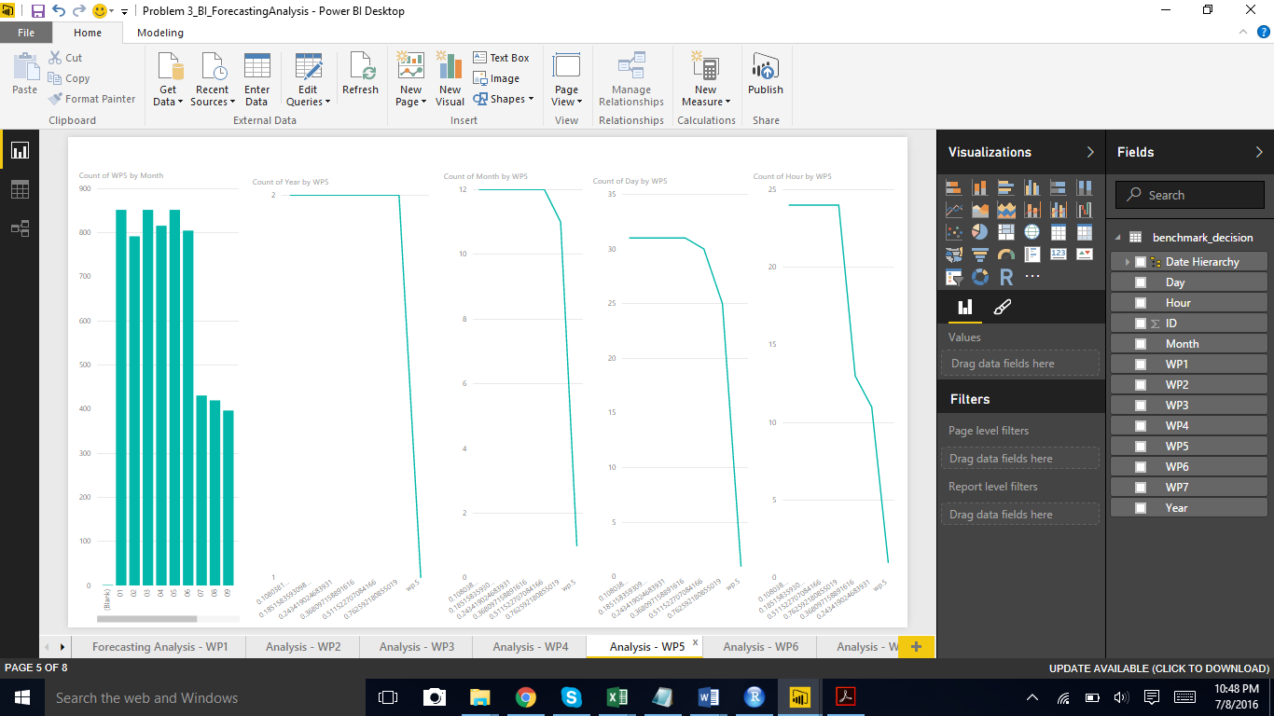

For the results of Windfarm 5, it is different from the previous 2 groups of forecasting pattern observed. There are 3 shifts in the decreasing rate for Day 25, 30 and 31.

**Windfarm Prediction 6-**

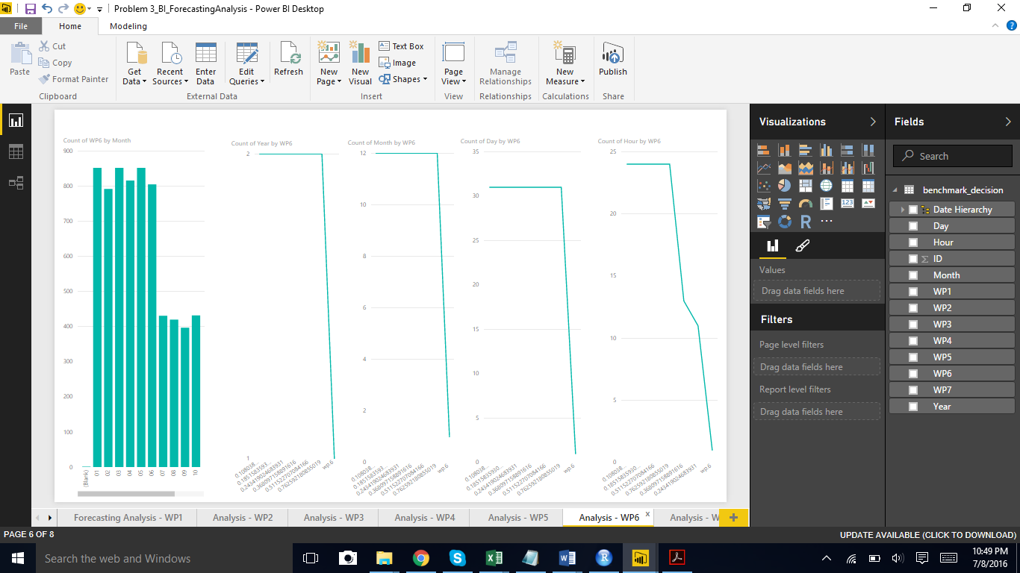

For the results of Windfarm 6, there is only 1 shifts in the decreasing rate for Day 31.

**Windfarm Prediction 7-**

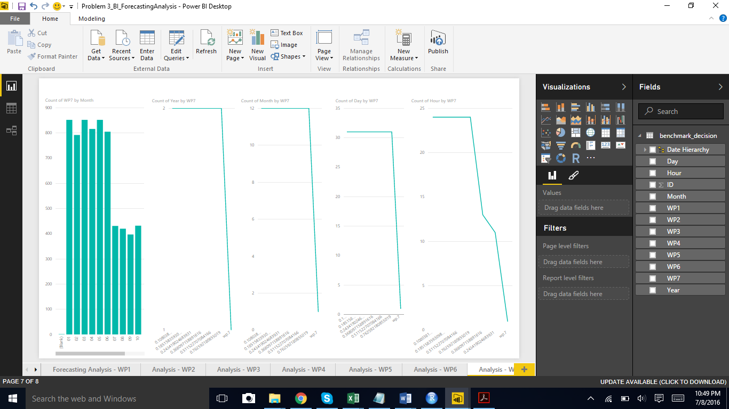

We also notice that the forecasting results of Windfarm 1 to Windfarm 3 are following a somewhat similar trend.

However, the results from Windfarm 4, Windfarm 6 and Windfarm 7 is very different from the pattern observed in Windfarm 1 to Windfarm 3. Windfarm 4, Windfarm 6 and Windfarm 7 are similar in the trend for changes.

For the results of Windfarm 7 also, there is only 1 shifts in the decreasing rate for Day 31.

Based on the shifts in the rate decrease for the windfarms, we may think of the reasons bringing to these changes.

It may that the operation hours require different work load on these windfarms.

Three decades of research in modeling and forecasting of power generation from the wind have led to a solid understanding of the whole chain from taking advantage of available meteorological and power measurements, as well as meteorological forecasts, all the way to using forecasts as input to decision-making. Today, methodologies are further developed in a probabilistic framework, even though forecast users may still prefer to be provided with single-valued predictions.

1. **Refrences**

* Kaggle.com: http://www.Kaggle.com
* Wikipidea.com
* Stackoverflow.com